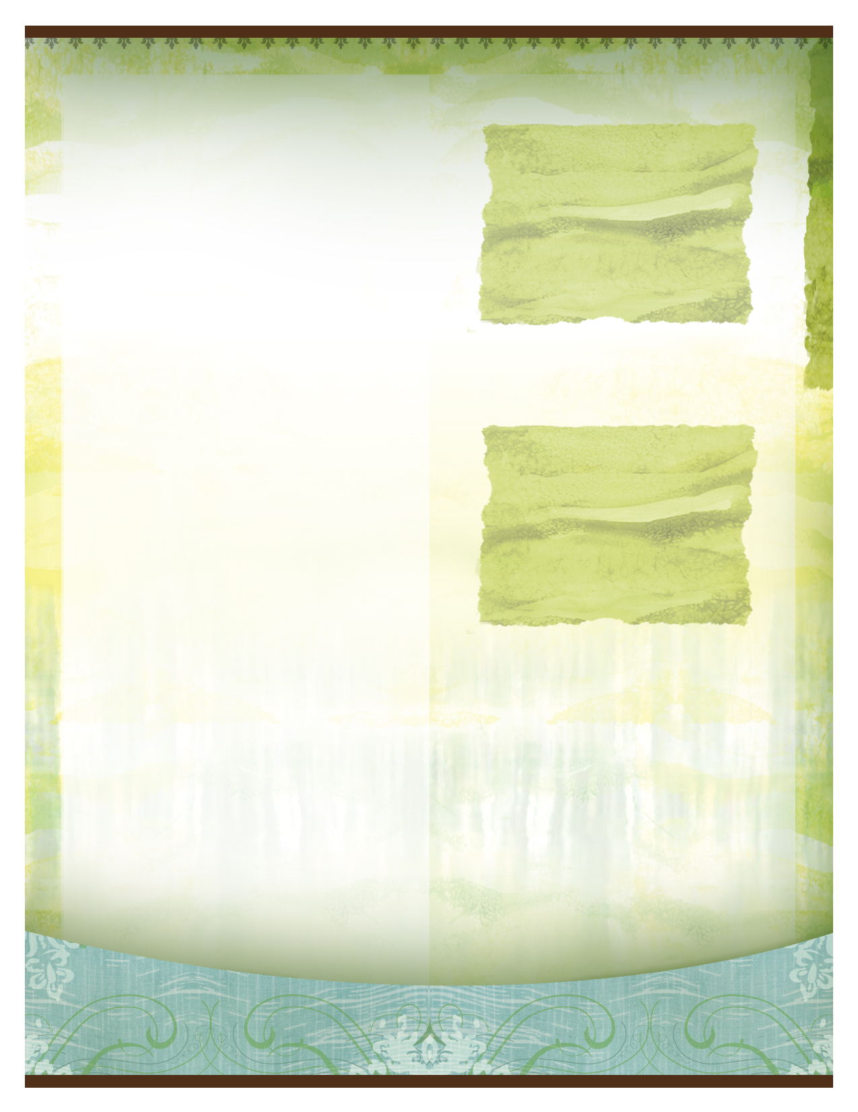
Energy Medicine 101


Delete text and photo here.

This class will be held in a private residence in
Virginia Beach, VA
Are you willing to spend one day learning ways to create a lifetime of healthy habits?

- Boost your vitality and stamina
- Strengthen your immune system
- Reduce your stress
- Nourish your Aura

This fun, interactive, one day class will cover many topics presented in Donna Eden's award-winning book, Energy Medicine. The topics covered: The Daily Energy Routine, 9 primary energy systems, meridians, neurolymphatic reflex points, triple warmer and spleen relationship (fight, flight or freeze response), staying grounded, and the auric field.

Massage therapists can earn 6 Contact Hours through NCBTMB for $10.00

Sandi Roberts has trained with Donna Eden and has taken her most advanced energy medicine classes. She is an Authorized EM101/102 Teacher, has a private practice and is an EEM Foundations instructor. She loves teaching and you will have fun learning and leave the class feeling empowered to take charge of your health.

Put Healing into Good Hands –
Your Own

November 2, 2013
9:30 am – 5:00 pm

W
Learn empowering techniques for more vitality and to enhance your health
Cost: $125.00

Registration Information:
www.sandiroberts.com
301.524.2269

Lots of time to practice the techniques
Plenty of opportunities to ask questions

